BIOLOGY

UNITS 3 & 4

2018

Name:

Teacher:

Time allowed for this paper

Reading time before commencing work: ten minutes
Working time: three hours

Materials required/recommended for this paper

To be provided by the supervisor

This Question/Answer booklet
Multiple-choice answer sheet

To be provided by the candidate
Standard items: pens (blue/black preferred), pencils (including coloured), sharpener, correction fluid/tape, eraser, ruler, highlighters

Special items: non-programmable calculators approved for use in this examination

Important note to candidates
No other items may be taken into the examination room. It is your responsibility to ensure that you do not have any unauthorised material. If you have any unauthorised material with you, hand it to the supervisor before reading any further.

Structure of this paper

Section | Number of questions available | Number of questions to be answered | Suggested working time (minutes) | Marks available | Percentage of examination
Section One Multiple-choice | 30 | 30 | 40 | 30 | 30
Section Two Short answer | 5 | 5 | 90 | 100 | 50
Section Three Extended answer Part A | 2 | 1 | 50 | 40 | 20
Part B | 2 | 1
 |  |  |  | Total | 100

Instructions to candidates

1. The rules for the conduct of the Western Australian Certificate of Education ATAR course examinations are detailed in the Year 12 Information Handbook 2018. Sitting this examination implies that you agree to abide by these rules.

2. Answer the questions according to the following instruction.

Section One: Answer all questions on the separate Multiple-choice answer sheet provided. For each question, shade the box to indicate your answer. Only use a blue or black pen to shade the boxes. If you make a mistake, place a cross through that square, then shade your new answer. Do not erase or use correction fluid/tape. Marks will not be deducted for incorrect answers. No marks will be given if more than one answer is completed for any question.

Section Two: Write your answers in this Question/Answer booklet. Wherever possible, confine your answers to the line spaces provided.

Section Three: Consists of two parts each with two questions. You must answer one question from each part. Tick the box next to the question you are answering.
Write your answers in this Question/Answer booklet.

3. You must be careful to confine your answers to the specific questions asked and to follow any instructions that are specific to a particular question.

4. Supplementary pages for the use of planning/continuing your answer to a question have been provided at the end of this Question/Answer booklet. If you use these pages to continue an answer, indicate at the original answer where the answer is continued, i.e. give the page number.

Section One: Multiple-choice 30% (30 Marks)

This section has 30 questions. Answer all questions on the separate Multiple-choice answer sheet provided. For each question, shade the box to indicate your answer. Use only a blue or black pen to shade the boxes. If you make a mistake, place a cross through that square, then shade your new answer. Do not erase or use correction fluid/tape. Marks will not be deducted for incorrect answers. No marks will be given if more than one answer is completed for any question.

Suggested working time: 40 minutes.

1. DNA ligase is used extensively in recombinant DNA technologies. The function of DNA ligase in these processes is to

(a) identify the recognition sites on the foreign DNA to isolate the required gene.
(b) ‘cut’ the DNA at the correct base pairs to produce DNA fragments.
(c) identify the restriction site on the plasmid DNA.
(d) join the foreign and plasmid DNA together at the complementary base pairs.

2. The various stages of mitosis are outlined in the list below.

A – nuclear membrane breaks down
B – chromosomes condense and become visible
C – chromosomes align at the equator of the cell
D – nuclear membranes form around separated chromosomes
E – centrioles produce spindle fibres that attach to the centromere of each chromatid
F – sister chromatids are separated and move to opposite poles

Which of the following shows the correct sequence of events for mitotic division?

(a) E – A – B – D – F – C
(b) B – A – E – C – F – D
(c) C – A – B – E – F – D
(d) A – E – B – C – D – F

3. Which of the following statements regarding meiosis is incorrect?

(a) Meiosis I produces two haploid cells.
(b) Crossing over occurs in meiosis I.
(c) Meiosis I is the same as mitosis.
(d) Four haploid cells are created in meiosis II.

4. Binary fission is a type of asexual reproduction that is carried out by

(a) prokaryotes only.
(b) all prokaryotes and some eukaryotes.
(c) eukaryotes only.
(d) most prokaryotes and unicellular eukaryotes.

5. Okazaki fragments are short segments of DNA that are involved in

(a) replication.
(b) transcription.
(c) translation.
(d) gel electrophoresis.

6. The protein-coding sequence used to synthesise new polypeptides is found on

(a) mRNA.
(b) the template strand.
(c) the coding strand.
(d) tRNA.

7. Non-coding segments of DNA are termed

(a) anticodons.
(b) exons.
(c) Watson and Crick fragments.
(d) introns.

8. Which of the following are involved in gene expression?

S – triplets
T – tRNA
U – DNA polymerase
V – polypeptide
W – identical daughter cells

(a) S, U and V
(b) S, T and V
(c) U, V and W
(d) S, U and W
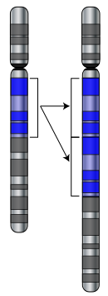

Question 9 and 10 relate to the diagram below.
W

X

9. The areas labelled ‘X’ on the diagram represent

(a) homologous chromosomes.
(b) loci.
(c) genes.
(d) nucleotides.
10. What type of mutation is occurring at ‘W’?

(a) Deletion
(b) Translocation
(c) Duplication
(d) Insertion

11. The four major factors that generate evolution in populations of species are

(a) population increase, genetic variation, competition and proliferation.
(b) natural selection, inheritance, genetic variation and reproductive success.
(c) genetic variation, competition, adaptation and inheritance.
(d) competition, population increase, mutation and survival.

12. Extensive bushfires in 2015 destroyed 90% of the Western Ground Parrot’s habitat. The population was reduced to 150 individuals, confined to a small area of heathland on Western Australia’s south coast. This dramatic decrease in the parrot population is referred to as

(a) gene flow.
(b) a genetic bottleneck.
(c) natural selection.
(d) disruptive selection.

13. The fossil record shows that

(a) primitive fossils are found in more recent stratum.
(b) evolution has been relatively stable.
(c) modern species are vastly different to their ancestors.
(d) rates of evolutionary change have been variable.

Question 14 relates to the diagram below.

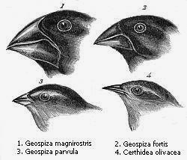

14. According to Charles Darwin, the finches of the Galapagos, shown in the diagram above, evolved from a single ancestor. This process of evolution, whereby all available niches are rapidly colonised, is called

(a) adaptive radiation.
(b) the founder effect.
(c) directional selection.
(d) migration.
15. New vaccines for influenza are produced every year due to the evolution of new virus strains. Which factor is most likely to favour the development of a new influenza virus strain?

(a) Gene flow
(b) Random mating
(c) Large population
(d) Mutation

16. The common kangaroo tick, Amblyomma triguttatum, is an eight-legged terrestrial invertebrate that feeds on the blood of mammals such as kangaroos, wallabies, lizards and humans. They inhabit bushland of most states in Australia and can play a role in the transmission of disease. The tick could therefore be described as a/an

(a) obligate parasite.
(b) host.
(c) parasitic vector.
(d) infectious invertebrate vector.

17. A reduction in the herd immunity of a population is likely the result of

(a) an effective immunisation program.
(b) a decrease in immunisation rates.
(c) the overuse of prescription antibiotics.
(d) an epidemic.

18. Which of the following terms refers to the capacity of a pathogen to cause disease?

(a) Pathenogenicity
(b) Infectivity
(c) Virulence
(d) Epidemiology

19. In Australia, strict quarantine procedures are carried out at state borders. The main reason for this is to

(a) reduce the transmission of communicable diseases between isolated populations.
(b) protect the agricultural food industry by preventing the import and export of contaminated produce.
(c) identify and disinfect vehicles carrying pathogen-infected soil on their tyres and undercarriage.
(d) identify individuals attempting to transport illicit substances throughout the country.

20. Which of the following best reflects the physiological response of an ectotherm to low atmospheric temperatures?

(a) Shivering
(b) Vasodilation
(c) Burrowing
(d) Reduced metabolic activity

21. Advances in biotechnology allow scientists to test the human foetal genome for inheritable diseases. This type of genetic screening would be best conducted using

(a) amino acid sequencing.
(b) molecular hybridisation.
(c) gene probes.
(d) gel electrophoresis.

22. In underdeveloped countries, the incidence of gastrointestinal infections following extreme weather events could be reduced significantly by

(a) treating infected individuals with antibiotics.
(b) practising safe sex.
(c) implementing widespread immunisation programs.
(d) treatment of drinking water.

23. Which of the following animals are likely to possess adaptations for counter- current heat exchange to prevent the adverse effects of cold temperatures?

(a) Dolphins, penguins and flamingos.
(b) Polar bears, emus and rabbits.
(c) Whales, giraffes and tuna.
(d) Kangaroos, pythons and dingoes.

24. Australian bat lyssavirus poses a threat to any mammal that comes into contact with an infected bat. This is because

(a) infected bats are more likely to show aggressive behaviour.
(b) the virus is zoonotic.
(c) transmission of the virus is through indirect methods.
(d) infected bats produce toxic saliva that can irritate the skin.

25. Which of the following features of bacteria supports antibiotic resistance?

(a) Variation in size and shape of cells.
(b) Slow reproduction rates.
(c) Transmissible plasmids.
(d) Lack of nuclear envelope.

The graph below shows the relationship between average annual rainfall of amphibian habitats and relative incidence of Amphibian Chytrid Fungus Disease.

26. Which of the following statements supports the information displayed in the graph above?

(a) Rainfall has no effect on the transmission of Amphibian Chytrid Fungus Disease.
(b) There is a negative correlation between the incidence of disease and annual rainfall.
(c) There is a positive correlation between the incidence of disease and annual rainfall.
(d) The presence of water in an amphibian’s habitat has no influence over the transmission or incidence of Amphibian Chytrid Fungus Disease.

27. Which cellular process is PCR (Polymerase chain reaction) most similar to?

(a) Transcription
(b) DNA replication
(c) Mitosis
(d) Meiosis

Questions 28 to 30 relate to the graph below.

Mass specific metabolic rate (mL O₂ per gram per hour)

Mass of mammal (kg)

28. Which of the following statements best describes the relationship shown in the graph?

(a) The larger the animal, the greater its oxygen consumption per unit mass.
(b) The smaller the animal, the greater its oxygen consumption per unit mass.
(c) The metabolic rate of any animal is directly proportional to its mass.
(d) The mass of an animal is dependent upon how much oxygen it consumes.

29. Each point on the graph represents a different type of mammal. Which mammal is likely to be represented by the point marked ‘X’?

(a) Rhinoceros
(b) Kangaroo
(c) Lion
(d) Field mouse

30. If this data were part of a scientific investigation, what is the independent variable?

(a) Metabolic rate
(b) Oxygen consumption
(c) Mass of mammal
(d) Species of mammal

End of Section One
Section Two: Short answer 50% (100 Marks)

This section has five (5) questions. Answer all questions. Write your answers in the spaces provided in this Question/Answer booklet. Wherever possible, confine your answers to the line spaces provided. Use a blue or black pen for this section. Only graphs and diagrams may be drawn in pencil.

Supplementary pages for the use of planning/continuing your answer to a question have been provided at the end of this Question/Answer booklet. If you use these pages to continue an answer, indicate at the original answer where the answer is continued, i.e. give the page number.

Suggested working time: 90 minutes.

Question 31 (20 marks)

(a) Label parts (J) to (M) using the diagram of the DNA molecule below. (4 marks)
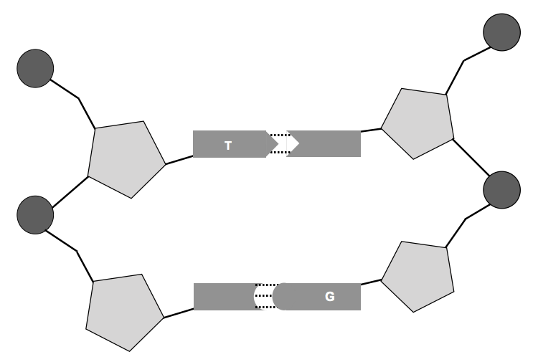

M
J

K

L

J -

K -

L -

M -

(b) Identify the feature of DNA that enables the process of gel electrophoresis to be carried out. (1 mark)

(c) Outline the main purpose of gel electrophoresis in DNA analyses. (2 marks)

Red-tailed Black Cockatoos are endemic to Western Australia and listed as ‘Vulnerable’ under the Federal Environmental Protection and Biodiversity Conservation Act. In addition to enduring habitat loss and competition for resources with exotic birds, the Red-tailed Black Cockatoo is targeted by breeders and bird traffickers. Nests are raided for eggs and juvenile birds are either sold within Australia or smuggled out of the country for illegal trade on the international market.

The juvenile birds and eggs that are retrieved by authorities can undergo forensic analyses to determine their place of origin.

(d) Give a brief description of how gel electrophoresis can aid in the identification of a bird’s original habitat. (6 marks)

A PhD student was undertaking a research project on the evolution of black cockatoos in Australia. She obtained mitochondrial DNA samples from five (5) different species to establish a DNA profile. The species are as follows;

A – Carnaby’s Black Cockatoo (Calyptorhynchus latirostris)
B – Baudin’s Black Cockatoo (Calyptorhynchus baudinii)
C – Red-tailed Black Cockatoo (Calyptorhynchus banksii)
D – Yellow-tailed Black cockatoo (Calyptorhynchus funereus)
E – Glossy Black Cockatoo (Calyptorhynchus lathami)

The mitochondrial DNA profiles of each cockatoo species are visible on the ‘gel’ diagram below.
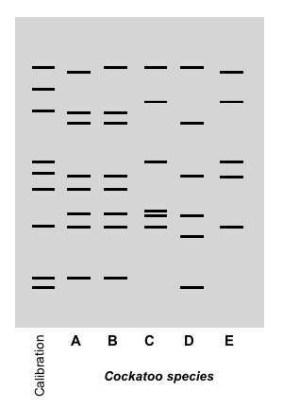

(e) Determine the relatedness of each cockatoo species using the banding pattern on the diagram above. Place the name of each species in the correct position on the following cladogram. (5 marks)

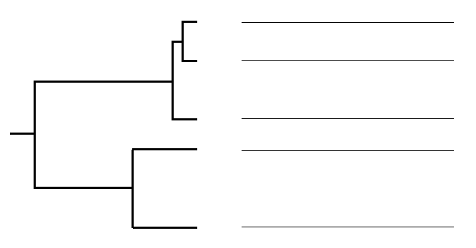

(f) Identify two (2) benefits of using mitochondrial DNA in molecular genetics. (2 marks)

Question 32 (20 marks)

Haemophilia is a recessive, sex-linked genetic disease that is passed down through families. Around one-third of cases diagnosed appear in families with no apparent history. Haemophilia A, or classical haemophilia, is caused by a deficiency in clotting factor VIII in the blood. As a result, sufferers can experience excessive bleeding both internally and externally. In Australia, there are approximately 2,700 people who suffer from haemophilia in varying degrees.

(a) Explain what is meant by ‘sex-linked’ in relation to genetic disorders. (2 marks)

Consider the pedigree below.

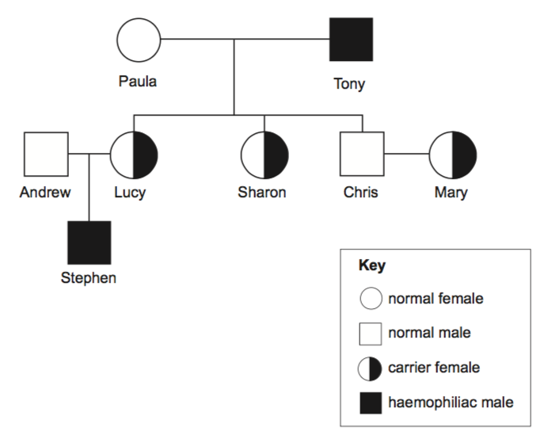

Robert
Jessica

Harrison

Nina
Max
Alyssa
Poppy

Jackson

(b) Explain why Harrison does not have haemophilia while his father Robert is a sufferer.
(3 marks)

(c) Jackson’s mother Nina is a carrier for the haemophilia gene. Nina discovers she is pregnant and visits a genetic counsellor to discuss her options. Using the Punnett Square below, show the possible genotypes and phenotypes of the foetus Nina is carrying. X^{H}Y designates an unaffected male, while X^{H}X^{h} a carrier female.

Genotypes: (4 marks)

Phenotypes: (4 marks)

(d) The life expectancy of a person with haemophilia has increased dramatically since the beginning of last century. As a result, the number of haemophiliacs in populations has also increased. Explain how modern medicine has altered the gene pool for haemophilia. (3 marks)

Until the 1990’s, blood products used to synthesise blood-clotting treatments for haemophiliac suffers were obtained from unscreened donors. Screening donor blood was not introduced until 1992.

(e) Explain the importance of screening donor blood in modern society. (2 marks)

(f) Suggest how the use of recombinant DNA technologies in the production of haemophilia treatments can decrease the likelihood of adverse health problems.
(2 marks)

Question 33 (20 marks)

Marine iguanas (Amblyrhynchus cristatus) are endemic to the Galapagos Islands, situated in the Pacific Ocean off the coast of Ecuador. The marine Iguana is classified as a marine reptile as it is the only species of iguana to forage within the ocean. Even though the islands are located close to the equator, the waters are extremely cold due to the influence of ocean currents.

Marine iguanas are usually grey to black in colour and can grow up to 75 centimetres in length. They live in colonies located near shallow reefs that lie within an extensive intertidal zone. The volcanic rocks bordering these reefs are covered with hundreds of iguanas basking in the morning sun. During the heat of the day, some individuals forage for green algae (seaweed) in the shallow reef while others can dive to around 12 metres. The diving iguanas are able to hold their breath for up to 30 minutes before they must return to the surface.
Iguana activity slows down in the late afternoon and they retire for the day by sheltering in rock crevices or under large boulders.

(a) Describe how marine iguanas regulate their body temperature through the following methods of heat transfer.

(i) Conduction (2 marks)

(ii) Convection (2 marks)

(iii) Evaporation (1 marks)

(iv) Radiation (2 marks)

(b) Explain why small marine iguanas must feed in the shallow intertidal zones while large marine iguanas are able to dive to 12 metres for up to 30 minutes. (4 marks)

(c) Explain how the temperature of the water could enable the iguanas to dive for long periods of time. (4 marks)

During their foraging, iguanas ingest large amounts of salt water. In order to maintain their internal osmotic potential, they secrete the excess salt from glands near their nose.

(d) Explain what would happen to the cells of the marine iguana if it could not excrete the excess salt it ingests. (2 marks)

(e) Describe how a marine fish, that also ingests salt water, maintains its internal osmotic potential. (3 marks)

Question 34 (20 marks)

(a) Explain the difference between an infectious and a non-infectious disease. (2 marks)

(b) In the last few years, there has been an increase in the number of people suffering from preventable diseases such as measles and Whooping cough. Discuss the possible causes for the increase in the incidence of these diseases. (3 marks)

(c) Construct a flow diagram that outlines the method by which a virus infects a cell.
(5 marks)

HIV is a retrovirus that first became prominent in the global community in the 1980’s. HIV causes AIDS (Aquired Immune Deficiency Syndrome) by attacking the immune system, making a person’s body more susceptible to infections.

A new drug called PrEP (pre-exposure prophylaxis) has been trialled in the UK to reduce the chance of contracting HIV. Over a period of eight years, from 2010 to 2017, approximately 7000 people were involved in the PrEP trial. These people were selected for the trial based on their lifestyle choices. Along with the HIV data, information regarding other STI's and unplanned pregnancies amongst the trial population was also collected.

The data from this trial is shown in the table below.

Table 1 - Relative number of new infections and unplanned pregnancies for trial participants using PrEP over an eight-year period.

Year | Relative number of affected individuals (per 100 people)
 | HIV | Other STI's | Unplanned pregnancies
2010 | 21 | 29 | 2
2011 | 19 | 36 | 4
2012 | 13 | 44 | 7
2013 | 12 | 39 | 9
2014 | 14 | 48 | 12
2015 | 9 | 57 | 12
2016 | 2 | 64 | 17
2017 | 3 | 68 | 21

(d) Construct an appropriate graph of the data presented in Table 1. (6 marks)



(e) Suggest two (2) major limitations in running human-based medical trials. (2 marks)

(f) Propose a possible explanation for the trend in the data presented in your graph.
(2 marks)

Question 35 (20 marks)

(a) Define ‘homeostasis’. (2 marks)

Two teenage boys were timing how long they could hold their breath under water.

(b) Construct a flow diagram outlining the physiological mechanism that stimulates the urge to breathe after a period of breath holding. (6 marks)

(c) Identify the type of response shown in this physiological mechanism. (1 mark)

Normal metabolic reactions produce by-products that can be toxic to cells. Nitrogenous waste is one such by-product.

(d) Identify how nitrogenous wastes are produced. (1 mark)

Animal | Nitrogenous waste | Explanation for waste type
Fish
Eagle
Rock wallaby

(e) Not all animals produce the same type of nitrogenous waste. Complete the table below, regarding the waste products for three (3) different animals. (6 marks)

(f) Identify the functional unit of the kidney. (1 mark)

(g) Explain how this functional unit differs in structure and function between a desert hopping mouse and a domestic dog. (3 marks)

End of Section Two
Section Three: Extended answer 20% (40 Marks)

This section contains four (4) questions.

Questions 36 and 37 are from Unit 3. Questions 38 and 39 are from Unit 4. Answer one (1) question from Unit 3 and one (1) from Unit 4.

Use a black or blue pen for this section. Only graphs and diagrams may be drawn in pencil. Responses can include: labelled diagram with explanatory notes; lists of points with linking sentences; labelled tables and/or graphs; and/or annotated flow diagrams with introductory notes.

Supplementary pages for the use of planning/continuing an answer to a question have been provided at the end of this Question/Answer booklet. If you use these pages to continue an answer, indicate at the original answer where the answer is continued, i.e. give the page number.

Suggested working time: 50 minutes

Unit 3

Choose either Question 36 or Question 37.

Indicate the question you will answer by ticking the box next to the question. Write your answer on pages 26 - 28. When you have answered your first question, turn to page 29 and indicate on that page the second question you will answer.

Question 36 (20 marks)

In modern agricultural practice, artificial selection and biotechnology are used to produce organisms with more desirable traits.

(a) Discuss the application of these two biotechnologies in 21st century farming with reference to their advantages and disadvantages. (10 marks)

Small populations of kangaroos kept in wildlife centres often produce offspring with albinism: an inherited condition seldom seen in the wild. These individuals are characterised by white fur and red eyes. Kangaroos exhibiting albinism do not produce the enzyme tyrosinase required for the production of melanin within melanocytes.

(b) Describe the normal cellular processes responsible for expressing genetic traits and identify how these processes are different in a kangaroo with albinism. (10 marks)

OR

Question 37 (20 marks)

The Honey possum, Tarsipes rostratus, is endemic to southwest Western Australia. It is the sole member of its genus and the family Tarsipedidae. The Honey possum's closest relative, Dromiciops gliroides, is a small, marsupial-like possum found in Chile, South America. Fossils of Dromiciops' ancestors have been discovered in South America, Antarctica and South Australia. The Honey possum is believed to be distantly related to Australian possums; both possess a prehensile tail. They also share similar features with wallabies, kangaroos and Dasyurids (carnivorous marsupials). However, the Honey possum has been evolving independently for approximately 40 million years.

(a) Discuss how scientists can establish an ancestral connection between Tarsipes rostratus and Dromiciops gliroides, utilising both traditional techniques and comparative genomics and biochemistry (that provide evidence for evolutionary relationships). (10 marks)

During the construction of a major highway, dissecting a large area of native bushland, a marsupial population is divided and becomes permanently isolated.

(b) Describe the possible effects of this scenario on the marsupial populations. In your discussion, suggest effective conservation techniques that could alter future outcomes for the species. (10 marks)

Question number

Unit 4

Choose either Question 38 or Question 39.

Question 38

(a) Describe how the structural, physiological and behavioural adaptations of terrestrial animals support thermoregulation. (10 marks)

Malaria is a disease caused by infection with a parasite. Malaria is widespread in many tropical and developing nations. It is the major cause of death in the Asia-Pacific region, infecting around 500 million people per year.

(a) Describe the lifecycle of the Malaria parasite. Include the symptoms and treatments for Malaria in your discussion. (10 marks)

OR

Question 39

Xerophytes live under extreme conditions whilst maintaining ‘normal’ metabolic processes.

(a) Describe how xerophytes are adapted to survive in hostile environments. (10 marks)

Mosquito-borne diseases require different management strategies than diseases spread by direct contact and other indirect methods. No single species of mosquito is responsible for the spread of disease; they are indiscriminate in their choice of host as they acquire nutrition.

(b) Discuss the management strategies used to control the spread of mosquito- borne diseases. Suggest how climate change could influence the future distribution of these diseases throughout the world. (10 marks)

Question number

Acknowledgements

Question 9

Wikimedia Commons, Public domain.

Question 14

Galapagos finches
Wikimedia Commons, Public domain.

Questions 26, 28, 31(a), 31 (e) and 32 (a).

Author made diagrams and graphs.

Question 31
White, N.E., et al. The evolutionary history of cockatoos (Aves: Psittaciformes: Cacatuidae). Molecular Phylogenetics and Evolution (2011), doi:10.1016/j.ympev.2011.03.011

Question 34

New Scientist - newscientist.com/issue/3108

